CHECKLIST FOR ROLLING SHUTTER Size: mm (W) x mm (H)
i) MECHANICAL CHECKPOINTS
PARTICULARS | Standard (mm)  As per quote/BOQ | Actual (mm) | Remark
Clear Width
Clear Height
Type of structure available
At site- RCC/BRICK/PEB/ PUF Panels
Left side/ Bearing side space
Availability
Right side/ Motor side space
Availability
Headroom space availability
Internal/ External Mountings
Electrical Supply type
Single phase/ Three phase

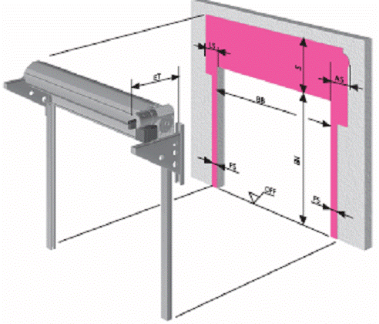
INSIDE ROOM

Sr | Unit | Dimensions in mm
1 | LS(left) | 300
2 | AS (right) | 600
3 | S (vertical up) | 500
4 | BB | Clear opening area
5 | B1 | Clear opening area
6 | PS (left) | 150
7 | PS (right) | 500
8 | ET | 750

Notes:
- All 3 sides should be flush with each other
- Wall or structural members required horizontally / vertically to support guide channels / shaft of the rolling shutter

